Module 3: Multi-Branch Response

Friday September 23, 2016:

2002 hours

Suspect 2, inside the gym, sends one hostage out with a message for Law Enforcement that he wants to be allowed to leave or he will shoot everyone one inside the gym. The hostage provides the suspect’s cell phone number and reports that there are eight other people inside, three of them have been shot. All victims were still alive when he was sent outside.

Upon further questioning, suspect 1 confirms with there are no other bombs or shooters on-scene.

2005 hours
Law Enforcement establishes a perimeter around the gym and is attempting to make telephone contact with the suspect.

The Rescue Task Force enters the Warm Zone and begins evacuating patients and victims.

2006 - 2015 hours
Patients are being triaged and are readied for transport as there are transferred to the Triage Group through the Casualty Collection Point

The Patient Transportation Group Supervisor (PTGS) provide the Disaster Control Facility with an initial patient count, based upon the patients listed on pages 13 to 16.

2010 hours
Law Enforcement establishes a telephone contact with suspect 2, who is being cooperative.

2012 hours
Law Enforcement conducts interviews with victims evacuated by the Rescue Task Force.

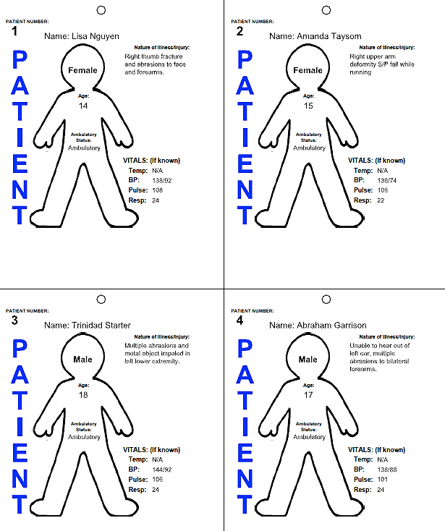

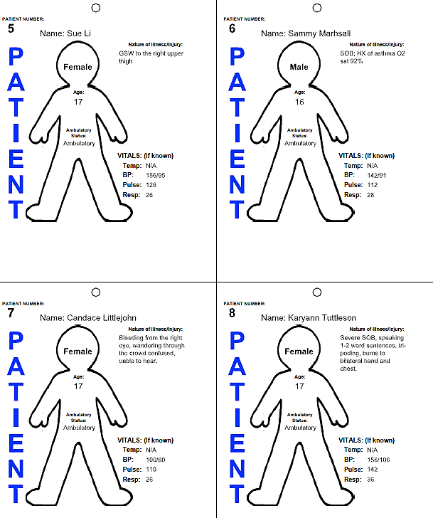

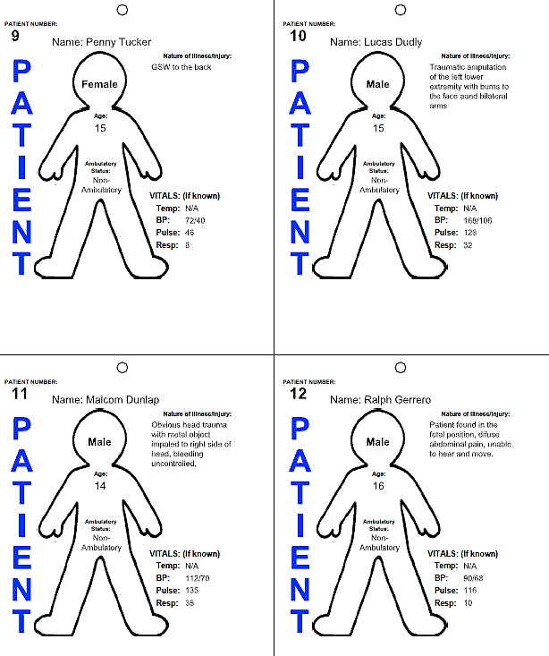

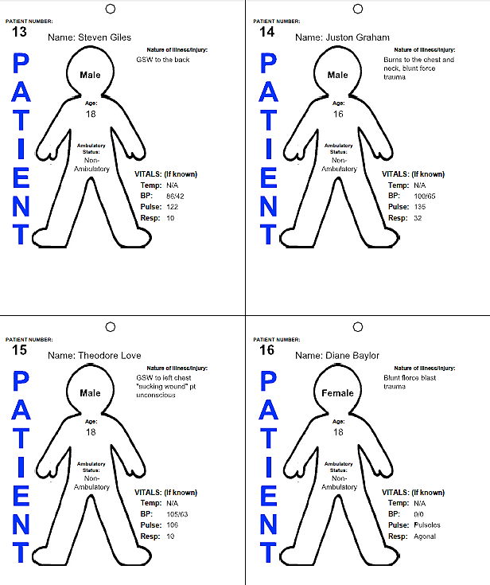

2030 hours
The Liter Bearers report to the Triage Unit Leader that all surviving patients have been evacuated. The following deceased patients were left where there were found, most of them appear to have been killed by the explosion:
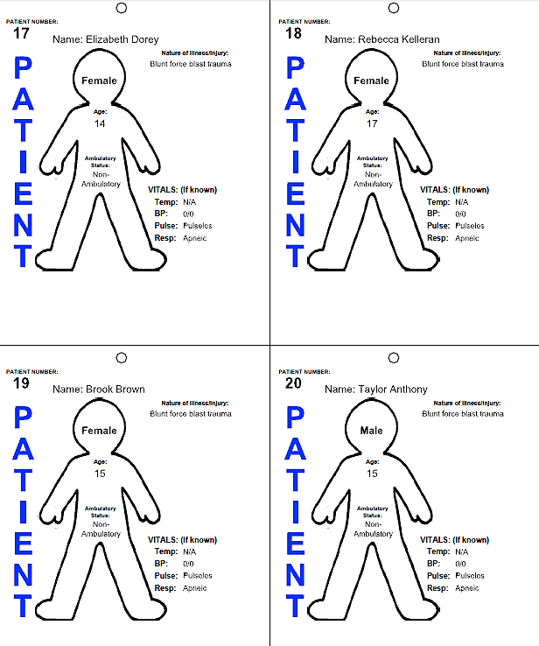
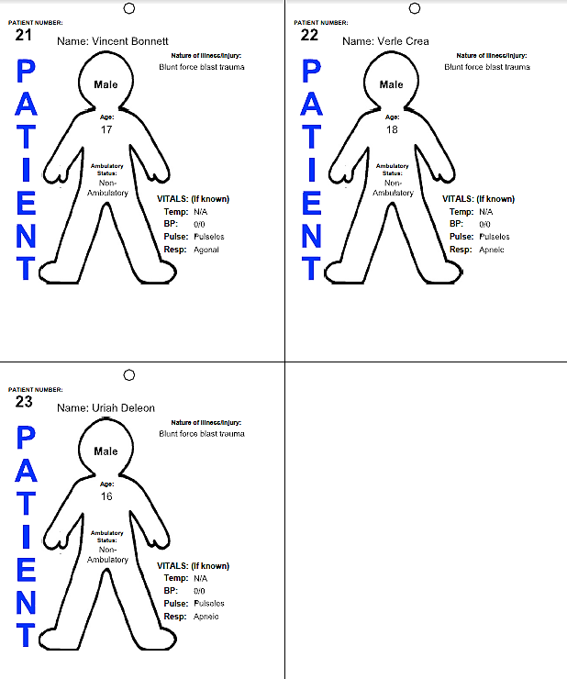

Key Issues
- The suspect 2 is still holding hostages, but is being cooperative with Law Enforcement.
- A total of 23 casualties have been confirmed in the Warm Zone around the stadium.
- Unconfirmed number and status of the victims inside the gym.

Questions
Based on the information provided, participate in the discussion concerning the issues raised in Module 3. Identify any critical issues, decisions, requirements, or questions that should be addressed at this time.

Instructions
Take 20 minutes to discuss the questions below. Assign a group scribe to document your group’s answers and a spokesperson to share your group’s findings.

- Has Unified Command been established at this time?

  - If yes, identify the Unified Incident Commanders

- If not already done, identify the locations of the following:

- Incident Command Post

- Hot Zone

- Warm Zone

- Cold Zone

- Perimeter

- Casualty Collection Point(s)

- Patient triage, treatment and loading areas

- Refuge Area

- Staging Areas

- Identify the traffic route for ambulance access and egress, to ensure the timely transport of patient off scene.

  - Describe any ambulance traffic routing challenges, and how they were resolved.

- Identify the incident priorities and objectives at this point.

  - Have they changed?

  - Update your ICS-201 Form, as needed.

- Identify how many casualties by START category have been confirmed:

Immediate:
Delayed:
Minor:
Deceased:

- Which ICS positions need to be filled at this time?

- Which agencies will fill each position?

