Module 2: Reinforced Response

Friday September 23, 2016:

1951 hours

The BLS ambulance on stand-by at the game has left the scene, and notifies dispatch of the situation.

1954 hours
Law enforcement arrives on scene. People are running and screeming as they flee the scene.

Fire and ALS ambulances arrive.

1955 hours
As the Contact Team approaches the football stadium they encounter a suspect with a handgun, who begins shooting at them. The suspect is wounded and is taken into custody. The suspect confesses to planting one bomb in the bleachers and that a second shooter is located on top of the gymnasium.

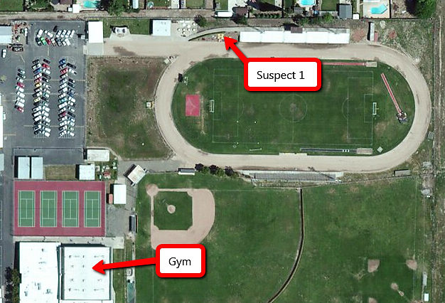

1957 hours

The location of the second suspect is relayed to additional Law Enforcement personnel, who converge upon the gymnasium. A witness runs out of the south door of the gym and reports that there is a guy shooting inside the men’s locker room with a rifle; and that at least three people have been shot.

Key Issues
- One suspect is in custody and has confessed to the bombing
- A second suspect is actively shooting inside the gym
- The number and severity of casualties is unknown

Questions
Based on the information provided, participate in the discussion concerning the issues raised in Module 2. Identify any critical issues, decisions, requirements, or questions that should be addressed at this time.

Instructions
Take 20 minutes to discuss the questions below. Assign a group scribe to document your group’s answers and a spokesperson to share your group’s findings.
- What are your priorities and incident objectives at this point

  - Have they changed?

  - Update your ICS-201 Form, as needed.

- Describe any additional resources needed at this time.

  - Explain the requesting process for each discipline involved.

  - How long will it take for the requested resources to arrive on scene?

  - Update the resource summary on your ICS-201 Form

- Identify the locations of staging area for incoming resources:

- Explain how the locations of staging areas will be communicated to incoming resources
- Explain how situational awareness will be shared with all response personnel on scene, in a timely manner.

  - Describe how on-scene interoperable communications is established?

- Identify the location of the following:

  - Incident Command Post

  - Hot Zone

  - Warm Zone

  - Cold Zone

  - Perimeter

  - Casualty Collection Point(s)

  - Patient triage, treatment and loading areas

  - Refuge Area

- How long until the first patient(s) will be transported to definitive care?

  - What steps are being taken to expedite patient transport?

- Has Unified Command been established at this time?

  - If yes, identify the Unified Incident Commanders

- Which ICS positions need to be filled at this time?

  - Which agencies will fill each position?

