San Joaquin County

Plausible Threat 2016

Tabletop Exercise -

Control Facility Operations

Situation Manual

August 11, 2016

This page intentionally left blank

Table of Contents
Exercise Overview 1
Preface 2
General Information 2
Module 1: Initial Event 5
Module 2: MCI – Update 10
Module 3: Patient Distribution 13
Appendix A: Exercise Schedule A-1
Appendix B: Acronyms B-1
Appendix C: EMS/BRN Evaluation Form C-1
Appendix D: Participant Feedback Form D-1

Exercise Overview
Exercise Name | San Joaquin County Plausible Threat 2016 Tabletop Exercise – Control Facility Operations
Exercise Date | August 11, 2016, 0800 to 1200 Hours
Scope | This exercise is a tabletop exercise, planned for four hours at the San Joaquin County Agriculture Center, Stockton, California.
Mission Area | Response
Core Capabilities | - Operational Coordination  - Operational Communications  - Public Health, Healthcare and Emergency Medical Services
Objectives | - Evaluate plans for patient distribution from a large scale Active Shooter/Hostile Event (Region IV MCI Plan).  - Evaluate hospital surge plans, including Operating Room surge.
Threat or Hazard | Active Shooter/Hostile Event (ASHE)
Scenario | Active Shooter/Hostile Event (ASHE) occurs during a high school football game.
Sponsors | San Joaquin County EMS Agency and San Joaquin Operational Area Healthcare Coalition.
Participating Organizations | Dameron Hospital, Doctor’s Hospital of Manteca, Kaiser Hospital Manteca, Lodi Memorial Hospital,, San Joaquin General Hospital, (Control Facility), St. Joseph’s Medical Center, and Sutter Tracy Community Hospital,. San Joaquin County EMS Agency and Behavioral Health Services.
Point of Contact | Phillip Cook  San Joaquin Emergency Medical Services Agency  P.O. Box 220,  French Camp, CA, 95231  209-468-6818  pcook@sjgov.org

Preface
The Plausible Threat 2016 Tabletop Exercise – Field Operations is sponsored by the San Joaquin County EMS Agency and San Joaquin Operational Area Healthcare Coalition. The exercise was designed to evaluate the San Joaquin County Active Threat Plan and to improve the response, management and mitigation of an Active Shooter/Hostile Event in San Joaquin County. This Situation Manual (SitMan) follows guidance set forth by the U.S. Department of Homeland Security (DHS) Homeland Security Exercise and Evaluation Program (HSEEP).

The Plausible Threat 2016 Tabletop Exercise – Control Facility Operations SitMan provides exercise participants with all the necessary tools for their roles in the exercise. It is tangible evidence of the San Joaquin County EMS Agency’s commitment to preparedness excellence through collaborative planning and exercises that will improve the survivability of victims of an Active Shooter/Hostile Event (ASHE).

The Plausible Threat 2016 Tabletop Exercise – Control Facility Operations is an unclassified exercise. Control of this exercise information is based on public sensitivity regarding the nature of the exercise rather than the actual exercise content. All exercise participants may view the SitMan.

General Information

Participant Roles and Responsibilities
The term participant encompasses many groups of people, not just those playing in the exercise. Groups of participants involved in the exercise, and their respective roles and responsibilities, are as follows:
- Players. Players are personnel who have an active role in discussing or performing their regular roles and responsibilities during the exercise. Players discuss or initiate actions in response to the simulated emergency.
- Observers. Observers do not directly participate in the exercise; however they may support the group in developing responses to the situation during the discussion.
- Facilitators. Facilitators provide situation updates and moderate discussions. They also provide additional information or resolve questions as required. Key Exercise Planning Team members also may assist with facilitation as subject matter experts (SMEs) during the exercise.
- Evaluators. Evaluators are assigned to observe and document certain objectives during the exercise. Their primary role is to document player discussions, including how and if those discussions conform to plans, polices, and procedures.

Exercise Structure
This exercise will be a multimedia, facilitated exercise. Players will participate in the following three (3) modules:
- Module 1: Initial Event
- Module 2: MCI Update #1
- Module 3: Patient Distribution

Each module begins with a multimedia update that summarizes key events occurring within that time period. After the updates, participants review the situation and engage in functional group discussions of appropriate response issues. For this exercise, the functional groups are as follows:
- Dameron Hospital
- Doctor’s Hospital of Manteca
- Kaiser Hospital Manteca
- Lodi Memorial Hospital
- San Joaquin General (Control Facility)
- St. Joseph’s Medical Center
- Sutter Tracy Community Hospital
- Behavioral Health

After these functional group discussions, participants will engage in a moderated plenary discussion in which a spokesperson from each group will present a synopsis of the group’s actions, based on the scenario.

Exercise Guidelines
- This exercise will be held in an open, low-stress, no-fault environment. Varying viewpoints, even disagreements, are expected.
- Respond to the scenario using your knowledge of current plans and capabilities (i.e., you may use only existing assets) and insights derived from your training.
- Decisions are not precedent setting and may not reflect your organization’s final position on a given issue. This exercise is an opportunity to discuss and present multiple options and possible solutions.
Issue identification is not as valuable as suggestions and recommended actions that could improve response efforts. Problem-solving efforts should be the focus.
During exercise discussions, if a player states that they are going to ask for/provide mutual aid, they need to state specifically under which plan and to which agency they will do so.

Exercise Assumptions and Artificialities
In any exercise, assumptions and artificialities may be necessary to complete play in the time allotted and/or account for logistical limitations. Exercise participants should accept that assumptions and artificialities are inherent in any exercise, and should not allow these considerations to negatively impact their participation. During this exercise, the following apply:
- The exercise scenario is plausible, and events occur as they are presented.
- There is no hidden agenda, and there are no trick questions.
- All players receive information at the same time.

Exercise Evaluation
Evaluation of the exercise is based on the exercise objectives. Players will be asked to complete participant feedback forms. These documents, coupled with facilitator observations and notes, will be used to evaluate the exercise and compile the After-Action Report (AAR).

Module 1: Initial Event

Friday September 23, 2016:

1930 hours
Paradise verses San Joaquin football game begins, hosted by the home team Paradise High School. There are approximately 650 people in attendance.

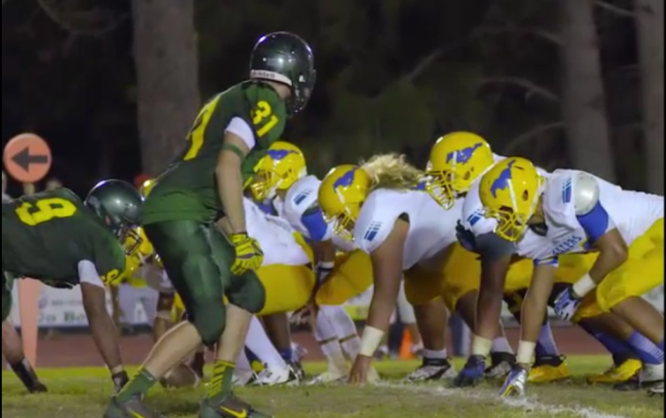
1948 hours
With 6:55 minutes remaining in the second quarter, an explosion in the home team bleachers occurs. Immediately following the explosion, gunshots are heard and several people are shot.

Panic ensues, spectators and players begin running in all directions. The location of the shooter(s) is unknown at this time.

The local PSAPs are inundated with 9-1-1 calls reporting the explosion and shooting. Additional gunshot can be heard in the background by one of the dispatchers receiving a call.

1950 hours
Law, Fire and EMS are dispatched to the incident.

1954 hours
Med Net Radio Traffic for the Control Facility:

“County Base, Medic 18 calling to declare an MCI”

“Medic 18 declaring an MCI, we have an active shooter and an explosion in progress, we will call this the Paradise Incident, I will be the Paradise Medical Group Supervisor, the patient count is evolving and I will call you back in approximately 5 minutes with the first round of triage to provide you patient numbers”.

Key Issues
- An unknown number of people have been injured by the explosion and gunshots
- The scene is in chaos
- The location of the shooter(s) is unknown
- The shooting actively continues

Questions
Based on the information provided, participate in the discussion concerning the issues raised in Module 1. Identify any critical issues, decisions, requirements, or questions that should be addressed at this time.

Instructions
Take 20 minutes to discuss the questions below. Assign a group scribe to document your group’s answers and a spokesperson to share your group’s findings.
- Control Facility
  - Create an event in EMResource for this MCI.

  - Describe the process for determining patient destinations from an MCI.

  - Which Control Facility positions have been filled at this time?
Control Facility Supervisor
Patient Dispersal Officer
Facility Status Officer
Receiving Facility Officer

- Hospitals:
  - How many patients can you take from this MCI?
San Joaquin County | Immediate | Delayed | Minor | Decon Facility | Surgeon Available
Dameron |  |  |  | Yes
Doctor’s Manteca |  |  |  | Yes
Kaiser Manteca |  |  |  | Yes
Lodi Memorial |  |  |  | Yes
San Joaquin General |  |  |  | Yes
St. Joseph’s |  |  |  | Yes
Sutter Tracy |  |  |  | Yes

  - Complete the Receiving Facility – Status Report Worksheet on the next page:

INSTRUCTIONS:

- PLACE INITIALS, OR A CHECK MARK, FOR EACH PERSON/BED AVAILABLE FOR MEDICAL TREATMENT BEGINNING WITH "IMMEDIATE TEAM" COLUMNS. WORK LEFT TO RIGHT.

- WHEN ALL POSITIONS FOR ANY TEAM ARE CHECKED, PLACE A CHECK MARK AT BOTTOM OF TEAM COLUMN BY "TOTAL PATIENT NUMBER."

- TRANSFER CHECK MARKS TO "DELAYED TEAM" COLUMNS FROM INCOMPLETE, OR UNNEEDED, "IMMEDIATE TEAMS." TRANSFER CHECK MARKS TO "MINOR TEAM" COLUMNS FROM INCOMPLETE OR UNNEEDED, "DELAYED TEAMS."

- SURGEONS NAMES MUST BE PROVIDED (for MCI Trauma). SURGEONS MUST BE IMMEDIATELY AVAILABLE TO REPORT TO THE RECEIVING FACILITY.

IMMEDIATE PATIENT TEAMS |  |  | ED STATUS  TOTAL PATIENTS ED CAN TREAT NOW  TIME: _________  DATE: ________  ______ IMMEDIATE  PATIENTS
TEAM # _____  ED PHYSICIAN _____  *SURGEON _____  NAME _______________  MICN/RN _____  ICU/ED LVN _____  Resp Tech _____  1 Ed Bed _____  1 _____ | TEAM # _____  ED PHYSICIAN _____  *SURGEON _____  NAME _______________  MICN/RN _____  ICU/ED LVN _____  Resp Tech _____  1 Ed Bed _____  2 _____ | TEAM # _____  ED PHYSICIAN _____  *SURGEON _____  NAME _______________  MICN/RN _____  ICU/ED LVN _____  Resp Tech _____  1 Ed Bed _____  3 _____

DELAYED PATIENT TEAMS
TEAM # _____  ED PHYSICIAN OR  SURGEON _____  NAME _____  MICN/RN _____  ICU/ED LVN _____  2 Ed Bed _____  2 _____ | TEAM # _____  ED PHYSICIAN OR  SURGEON _____  NAME _____  MICN/RN _____  ICU/ED LVN _____  2 Ed Bed _____  4 _____ | TEAM # _____  ED PHYSICIAN OR  SURGEON _____  NAME _____  MICN/RN _____  ICU/ED LVN _____  2 Ed Bed _____  6 _____ | ______ DELAYED  PATIENTS
MINOR PATIENT TEAMS
TEAM # _____  MICN/RN _____  LVN _____  ASSISTANT _____  5 _____ | TEAM # _____  MICN/RN _____  LVN _____  ASSISTANT _____  10 _____ | TEAM # _____  MICN/RN _____  LVN _____  ASSISTANT _____  15 _____ | _______ MINOR  PATIENTS

  - Explain how your hospital will accommodate the surge in trauma patients.

    - Describe how you would alert and notify hospital personnel of the activation of your medical surge plan

  - How many behavioral health patients do you typically have in your Emergency Departments on a Friday night?

  - Explain the process for clearing the behavioral health patients, in order to free up Emergency Departments beds

- Behavioral Health:

  - Describe the assistance you could provide the hospitals in clearing the behavioral health patients out of the Emergency Departments.

  - Explain the requesting process for assistance.

  - What are your concerns at this point in the incident?

Module 2: MCI Update

Friday September 23, 2016:

1959 hours

Med Net Radio Traffic for the Control Facility:
“County Base this the Paradise MGS with an update on the Paradise Incident”

“Paradise MGS the first sweep of triage had been completed; please keep in mind the patient count is evolving between 40-50 patients. At this time I have 19 patients accounted for with the following patient count and categories;
Immediate Pediatric = 1
Immediate Adult = 4
Delayed = 4
Minor = 10”

“I am ready for destinations for the 19 patients at this time”

2008 hours
Self presenting patients from the Paradise incident arrive at local hospitals.

2010 hours

Med Net Radio Traffic for the Control Facility:
“County Base this the Paradise MGS with an update on the Paradise Incident”

“Paradise MGS upon secondary assessment 1 delayed patient met major trauma triage criteria and they are now categorized as an immediate. Please confirm or change the destination for this patient”.

“Paradise MGS another round of triage is complete. At this time I have 10 additional patients accounted for, with the following patient count and categories that I will need additional destinations on;
Immediate Adult = 4
Delayed = 2
Minor = 4”

Key Issues
- There are a total of 29 patients from the MCI.
- Patient destinations are needed
- The incident scene has not be fully secured by Law Enforcement, there may be additional patients
- A large number of self-presenting patients, from the incident, have been arriving at local hospitals.

Questions
Based on the information provided, participate in the discussion concerning the issues raised in Module 2. Identify any critical issues, decisions, requirements, or questions that should be addressed at this time.

Instructions
Take 20 minutes to discuss the questions below. Assign a group scribe to document your group’s answers and a spokesperson to share your group’s findings.
- Control Facility
- Update EMResource.

- What are the current patient destinations

- Hospitals:
  - How many patients can you take from this MCI?
    - Has this changed since Module #1?
San Joaquin County | Immediate | Delayed | Minor | Decon Facility | Surgeon Available
Dameron |  |  |  | Yes
Doctor’s Manteca |  |  |  | Yes
Kaiser Manteca |  |  |  | Yes
Lodi Memorial |  |  |  | Yes
San Joaquin General |  |  |  | Yes
St. Joseph’s |  |  |  | Yes
Sutter Tracy |  |  |  | Yes

  - Explain your priorities at this point in the scenario.

  - Describe your process for handling the surge of self-presenting patients.

This page intentionally left blank

Module 3: Patient Distribution

Friday September 23, 2016:

2015 Hours
Total Patient Count = 29:
Immediate Pediatric = 1
Immediate Adult = 8 (one patient upgraded from a delayed)
Delayed = 5
Minor = 14

2030 hours

Med Net Radio Traffic for the Control Facility
“County Base this the Paradise MGS with an update on the Paradise Incident”

“Paradise MGS all patients have been transport off scene at this time. The MCI has ended”

Key Issues
- Hospitals are still being inundated by self-presenting patients
- Several patients, family members and other visitors are exhibiting signs of mental health issues as a result of this incident

Questions
Based on the information provided, participate in the discussion concerning the issues raised in Module 3. Identify any critical issues, decisions, requirements, or questions that should be addressed at this time.

Instructions
Take 20 minutes to discuss the questions below. Assign a group scribe to document your group’s answers and a spokesperson to share your group’s findings.

- Hospital:
  - Explain the actions being taken to accommodate the continued surge in self-presenting patients.

  - Describe how the behavioral health needs of patients, family members and visitors are being addressed at this time.

    - Does your surge plan address behavioral health surge?

- Behavioral Health

  - What assistance or resources can you provide hospitals at this time?

Appendix A: Exercise Schedule
Time | Activity
August 11, 2016
0730 - 0800 | Check-In and Registration
0800 - 0815 | Welcome and Exercise Overview
0815 - 0915 | Module 1: Initial Event
0915 - 0925 | BREAK
0925 - 1025 | Module 2: MCI Update
1025 - 1035 | BREAK
1035 - 1135 | Module 3: Patient Distribution
1135 - 1200 | Hot Wash, Wrap-up and Closing Comments

Appendix B: Acronyms

Acronym | Term
ALS | Advance Life Support
AAR/IP | After Action Report/Improvement Plan
ASHE | Active Shooter/Hostile Event
BLS | Basic Life Support
Cal OES | California Governor’s Office of Emergency Services
CSWC | California State Warning Center
CF | Control Facility
DHS | U.S. Department of Homeland Security
EMAC | Emergency Management Assistance Compact
EMS | Emergency Management Services
EMSA | California Emergency Medical Services Authority
ETA | Estimated time of arrival
FOUO | For Official Use Only
HSEEP | Homeland Security Exercise and Evaluation Program
IC | Incident Commander
ICS | Incident Command System
MCI | Multi-Casualty Incident
MGS | Medical Group Supervisor
MHOAC | Medical Health Operational Area Coordinator
MICN | Mobile Intensive Care Nurse
MSEL | Master Scenario Events List
NIMS | National Incident Management System
POC | Point of Contact
PSAP | Public Safety Answering Point (i.e., 9-1-1 call center)
PTGS | Patient Transportation Group Supervisor
RDMHC | Regional Disaster Medical Health Coordinator
RDMHS | Regional Disaster Medical Health Specialist
RTF | Rescue Task Force
SEMS | Standardized Emergency Management System
SitMan | Situation Manual
SME | Subject Matter Expert
TTX | Tabletop Exercise

Appendix C: EMS/BRN Evaluation Form
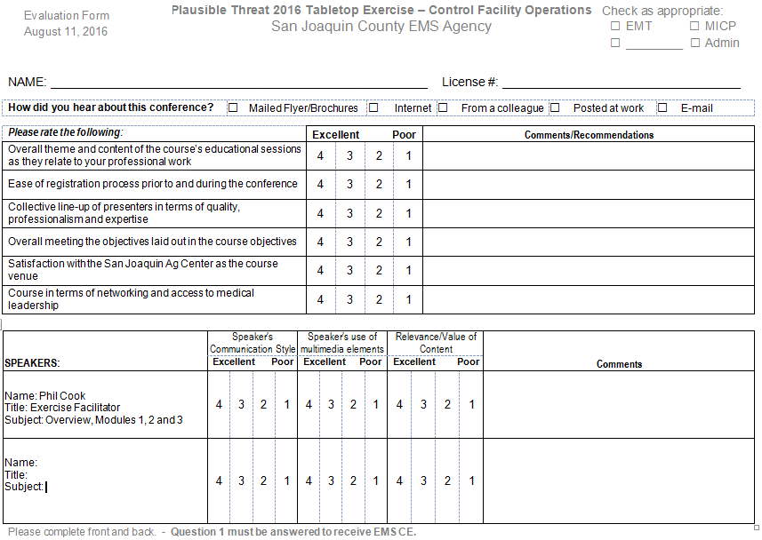
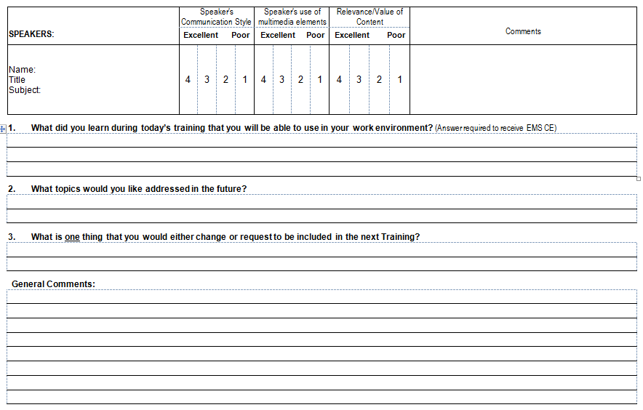

Appendix D: - Participant Feedback Form
Please enter your responses in the form field or check box after the appropriate selection.
Name: |  |  |  |  |  | Title:
Agency:
Role: | Player |  | Facilitator | Observer |  | Evaluator

Part I: Recommendations and Corrective Actions
- Based on the discussions today and the tasks identified, list the top three strengths and/or areas that need improvement.

- Identify the action steps that should be taken to address the issues identified above. For each action step, indicate if it is a high, medium, or low priority.
Corrective Action | Priority

- Describe the corrective actions that relate to your area of responsibility. Who should be assigned responsibility for each corrective action?
Corrective Action | Recommended Assignment

- List the policies, plans, and procedures that should be reviewed, revised, or developed. Indicate the priority level for each.
Item for Review | Priority

Part II: Assessment of Exercise Design and Conduct
Please rate, on a scale of 1 to 5, your overall assessment of the exercise relative to the statements provided below, with 1 indicating strong disagreement with the statement and 5 indicating strong agreement.
Assessment Factor | Strongly  Disagree |  |  | Strongly Agree
The exercise was well structured and organized. | 1 | 2 | 3 |  | 4 | 5
The exercise scenario was plausible and realistic. | 1 | 2 | 3 |  | 4 | 5
The multimedia presentation helped the participants understand and become engaged in the scenario. | 1 | 2 | 3 |  | 4 | 5
The facilitator(s) was knowledgeable about the material, kept the exercise on target, and was sensitive to group dynamics. | 1 | 2 | 3 |  | 4 | 5
The Situation Manual used during the exercise was a valuable tool throughout the exercise. | 1 | 2 | 3 |  | 4 | 5
Participation in the exercise was appropriate for someone in my position. | 1 | 2 | 3 |  | 4 | 5
The participants included the right people in terms of level and mix of disciplines. | 1 | 2 | 3 |  | 4 | 5

Part III: Participant Feedback
What changes would you make to this exercise? Please provide any recommendations on how this exercise or future exercises could be improved or enhanced.

https://www.fema.gov/mission-areas
https://www.fema.gov/core-capabilities

